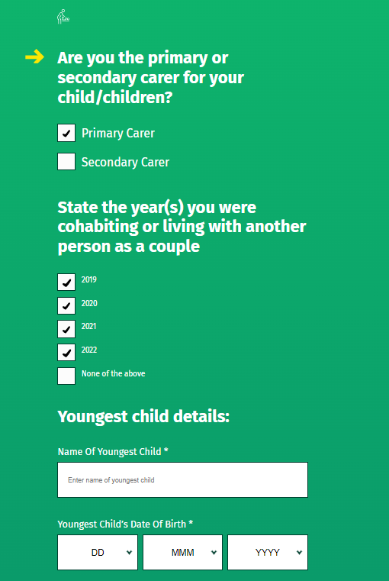Can we please change the years on the root and all sub versions for SPCC – the years should be   
  
2020  
2021  
2022  
2023  
  
Please also change the years on the CSV

Can we please change the years on the root and all sub versions for SPCC – the years should be

2020  
2021  
2022  
2023  
  
Please also change the years on the CSV

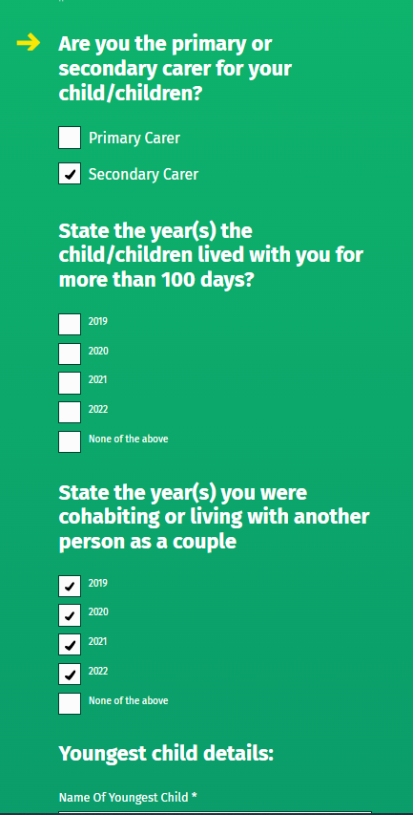

Can we change the years on incapacitated child, dependent relative, Home Carer on the root version and all sub versions to the years:  
  
2020  
2021  
2022  
2023

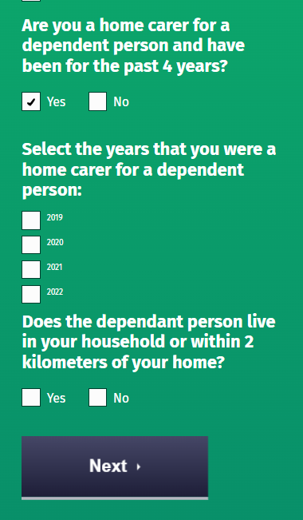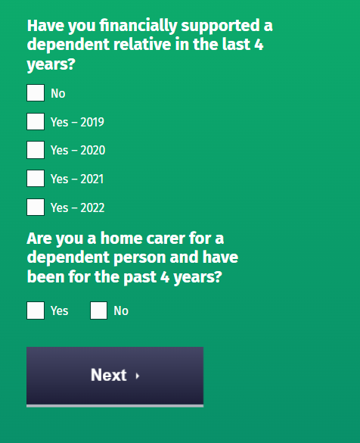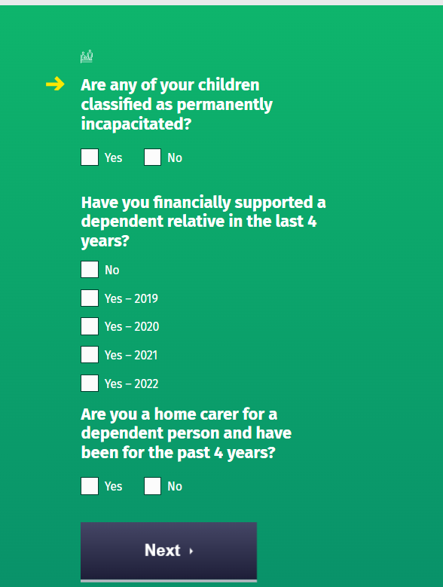Please also amend years on CSV

Can we change the years on Tuition fees on the root and all sub version to the years:  
  
2020  
2021  
2022  
2023

Please also amend years on the CSV

Can we change the years on Medical or Non-Routine expenses on the root and all sub version to the years including the amount paid:  
  
2020  
2021  
2022  
2023

Please also amend years on the CSV

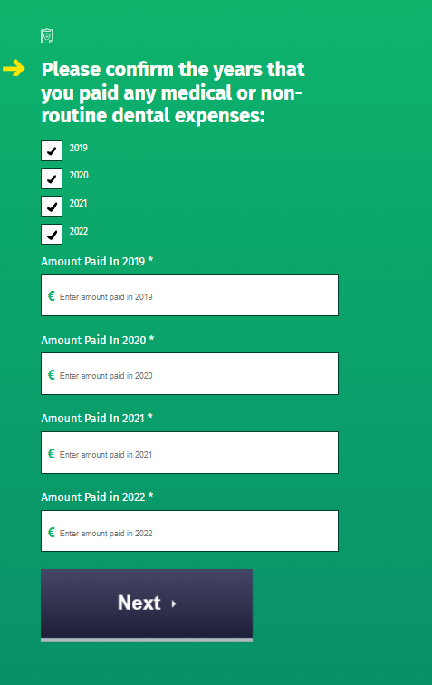

Can we change the years on Nursing home expenses on the root and all sub version to the years including the amount paid:  
  
2020  
2021  
2022  
2023

Please also amend years on the CSV

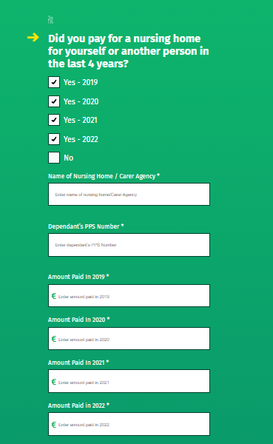

Can we change the years on Employ a carer on the root and all sub version to the years including the amount paid:  
  
2020  
2021  
2022  
2023

Please also amend years on the CSV

